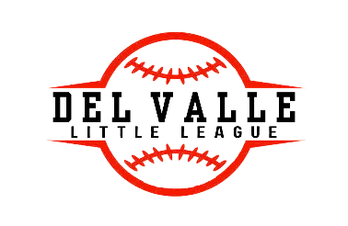
DEL VALLE LITTLE LEAGUE SPONSOR FORM

To our local businesses:
Del Valle Little League (DVLL) is seeking sponsors for the 2025 baseball/softball and t-ball season. We anticipate fielding several teams with players ranging from 4 years old to 12 years old. We are a non-profit organization serving Del Valle and the surrounding communities. Your sponsorship helps reduce the per-team cost of running the league. Almost any business, organization, group or individual can sponsor. DVLL sponsorship helps the league pay for the use of Travis County fields for games and practice, lights, equipment purchase and overall cost of running the league. DVLL promotes good sportsmanship and the National Little League tenants of character, courage and loyalty. Donations of any amount are greatly appreciated and welcomed.
Rookie Sponsor - Any donation from any business will provide the following: Your name or business name prominently displayed on the DVLL website: www.dvll.net on our Facebook page and a special announcement during home games highlighting your support.
Home Run Sponsor - A donation of $300 or more will provide the following. Your name or business name prominently displayed on the DVLL website: www.dvll.net, our Facebook page and a special announcement during home games highlighting your support. Your business will also have banner that will be displayed at home games.
Grand Slam Sponsor – A donation of $600 more will provide the following: Your name or business name prominently displayed on the DVLL website: www.dvll.net, our Facebook page and a special announcement during home games highlighting your support. Your business will have a banner displaying your business at home game. Your business will also receive a sponsorship patch on the jerseys of a single team of your choice. Someone from your business will have the opportunity to throw out the first pitch.
Hall of Fame Sponsor- A donation of $1,200 or more will provide the following: Your name or business name prominently displayed on the DVLL website: www.dvll.net, our Facebook page and a special announcement during home games highlighting your support. Your business will have a banner displaying your business at home game. Your business will also receive a sponsorship patch on ALL of the jerseys for the season. Our DJ will announce your business at our annual fundraiser, the Jamboree, during Spring Season. If donation is made in the fall the DJ will announce your business at our Monster Mash Bash fundraiser. You will also have the opportunity to throw out the first throw at Opening and Closing ceremonies.
Company/Organization _______________________________________________________
Contact name and phone number & email:_________________________________________
Which Sponsorship Level are you selecting:_________________________________________
Please make your check out to DVLL and fill out the information above and mail to:
DVLL Laura O’Neal 5512 Thunder Gulch Dr. Del Valle, TX 78617)

